Anmol More – 11915043

Sriganesh Balamurugan - 11915001

Raghu Punnamraju – 11915010

**[Project A - Required] Texxell would like to know how wholesale prices of TexPower® compare to competing premium grade products.**

• Conduct series of summary statistics/graphs regarding Texxell price differentials vs. competitor prices

**Trend Analysis**: Texxell has the following trend for the years provided.

* Both their premium and regular offerings’ prices have trailed respective other branded offerings.
* They made one correction in week 42 of 2009, where the difference between them and other branded companies was significantly cut.
* They made another correction in Wk #26 where they slightly exceeded other brands for both offerings.

|  |
| --- |
|  |
|  |
|  |

**Observation 2 :** **Across different states**

* We observed similar trailing trends were observed across all states except for in NY, where they consistently were ahead of their competition.
* The difference became more in 2010 Wk 50 of 2010
* When they did the overall price correction in 2011, they did not do the price correction for NY. This made them be on par with the rest of the competition

|  |
| --- |
|  |
|  |
|  |

**Correlation Observations:**

* We noticed that there was correlation between the Zip code and sales.
* Both unemployment indicators had correlation with the sales, but the unemployment rate was not significantly correlated. We could not really conclude anything based on that
* In 2011, we saw the prices were significantly impacted across all competition

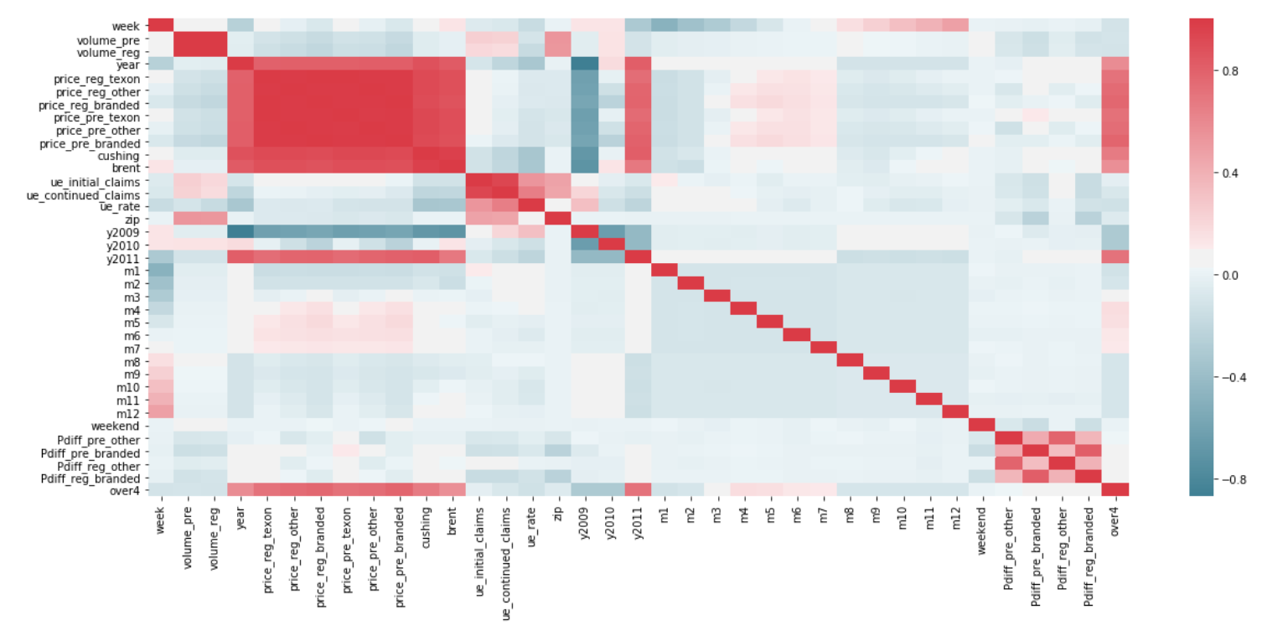

[Project C] Texxell’s marketing budget is currently allocated equally throughout the year. Texxell is interested in better aligning marketing expenditures with consumer travel patterns to focus on driving share during peak demand seasons. Identify opportunities for more effective allocation of marketing resources throughout the year and propose a marketing allocation strategy to Texxell.

**Ans:**

**Monthly Volume Trends:** We looked at the monthly volume trends

* A regression of their average monthly sales across over the month across the three years. We observed a clear impact of month on the sales. We used the month dummy variables and kept Jan as the reference month. We noticed low P-values across all months.
  + For e.g keeping all other variables constant, we could see that Aug has 575K more gallons sold compared to the sales in Jan of the year
  + However the low R square was highlighting the fact that only 0.5% could be explained by this regression.

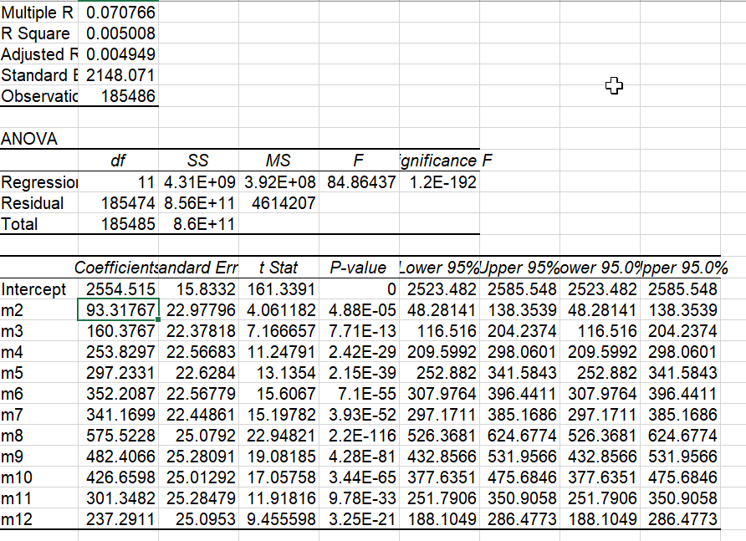

* When we plotted an average historgram over the 2.5 years, we got the trend confirmed that after July, their sales are going down.
  + 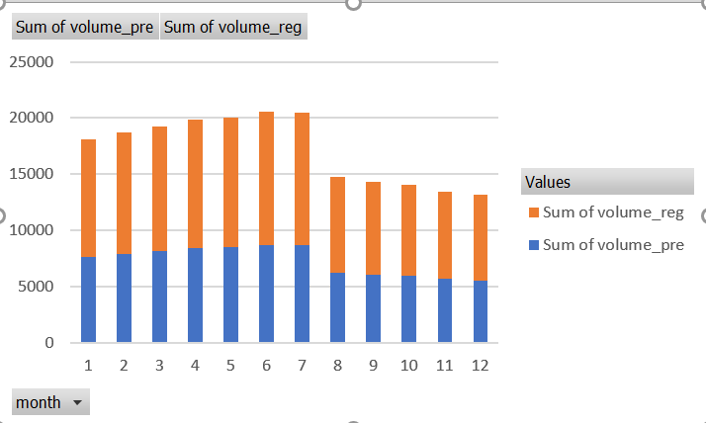
* However, when we did a deep dive by year, we saw that only inn 2009, there was a consistent trend towards the end of the year, with minor dip around the thanks giving time.
* There was a significant dip in the sales in 2010, this was around the same time they did a price correction and increased the price to stay close the competition. This definitely seemed to have an impact on their sales.
* They started recovering from that impact from Jun 2011 and we see the positive trend coming back.
* **In summary**
  + If we ignore the price correction impact, in 2010, there is a positive trend from the beginning of the year towards the end of the year. We see the same trend continuing in 2011 too.
  + The increasing trend from the beginning towards the end of the year could be explained by the seasonality of Summer(School holidays), Labor weekend, Thanksgiving and Christmas
  + We recommend them split their $65M budget as follows
    - Increase the spend by in First quarter (Jan-March) of every year so that they can reduce the dip levels
    - Increase the spend in 3rd quarter to attain maximum sales during summer time.
    - Decrease the spend in 2nd and 4th quarters and spend just enough
      * to make sure we don’t lose Thanks giving and Christmas timeframe
      * to maintain the elevated levels from first quarter.

|  |
| --- |
|  |
|  |
|  |